Date: 18/11/2020

**Practical no 9**

**AIM**: Write a JAX-WS web service to perform the following operations. Define a

Servlet / JSP that consumes the web service.

**Note**: To do this practical, follow the steps from 1 to 18 present in practical – 7.

After that do not close or restart the NetBeans.

**Steps :-**

1. Create an another Web Application project and Give name as Consumer**.**

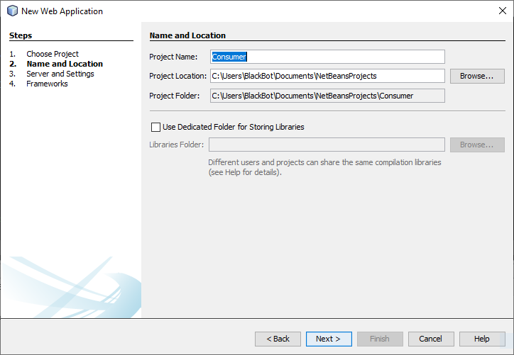

2) And create it. Next Finish.

3) Now right click on index.html and delete it.

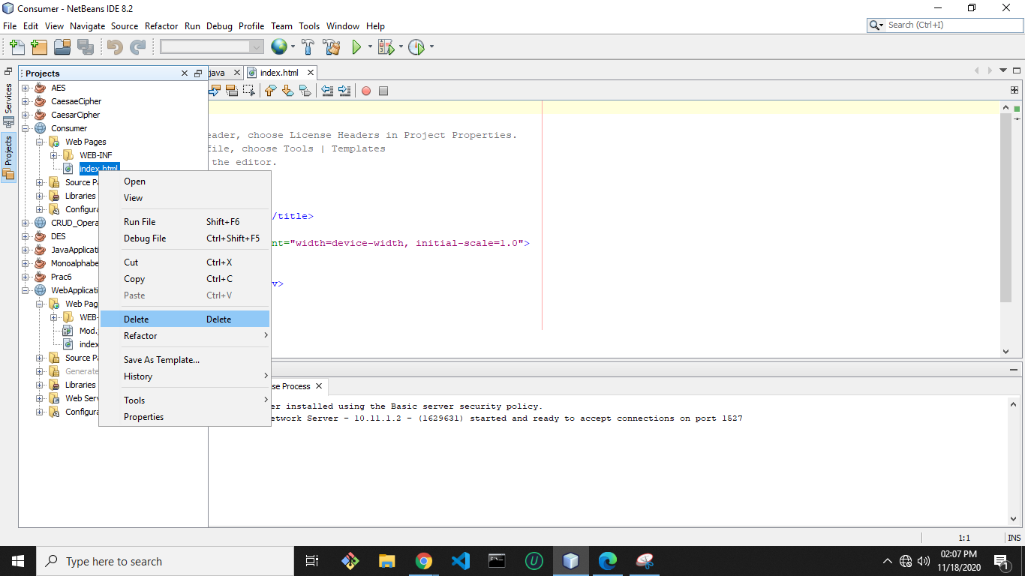

4) Now right click on Web Pages and select JSP to add a JSP page.

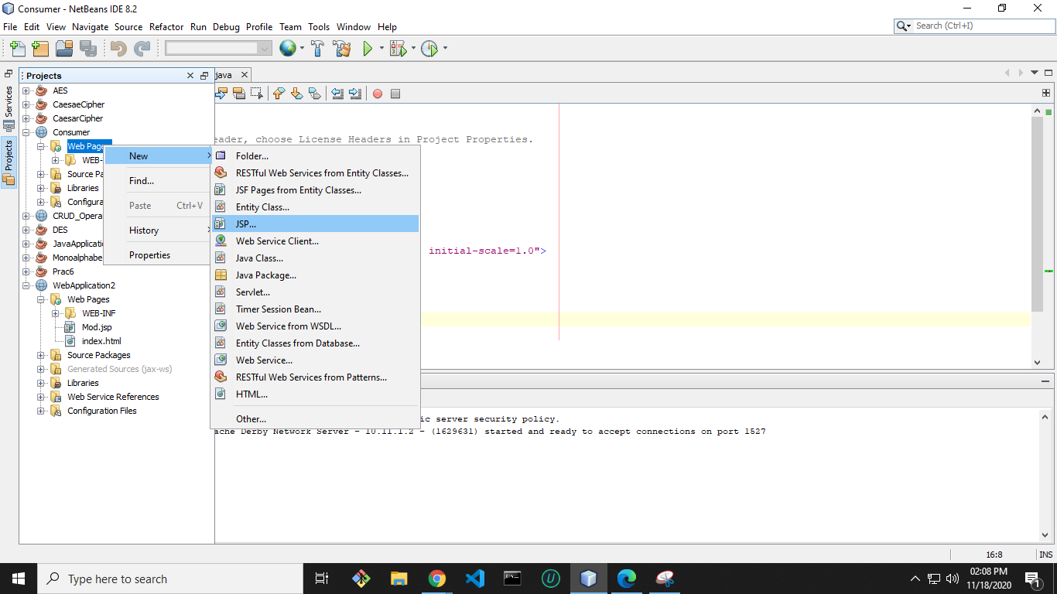

5) Give index name to it and then click on Finish.

6) Now index.jsp page will open like below.

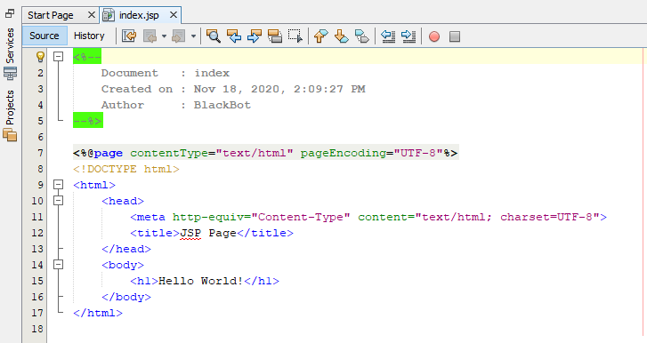

7) Now select HTML content of index.jsp file and replace it with following bold

letter codes.

|  |
| --- |
| <%@page contentType="text/html" pageEncoding="UTF-8"%>  <!DOCTYPE html>  <<HTML>  <HEAD>  <script language="javascript"> var xmlhttp;  function init()  {  xmlhttp=new XMLHttpRequest();  }  function readLocal(){ if(window.localStorage){  var seller=localStorage.getItem("seller");  seller=JSON.parse(seller);  document.getElementById("firstName").value=seller.firstName;  document.getElementById("sellerid").value=seller.id;  }  }  function saveLocal()  {  var sellerid=document.getElementById("sellerid");  var url="http://localhost:8080/CRUD_Operation/webresources/com.kk.seller/"+ sellerid.value;  xmlhttp.open('GET',url,true); xmlhttp.send(null);  xmlhttp.onreadystatechange =function(){  if(xmlhttp.readyState===4){alert("6"+sellerid);  if(xmlhttp.status===200){alert("7"+sellerid);  var seller =eval("("+xmlhttp.responseText+")");  if(window.localStorage){  localStorage.setItem("seller",JSON.stringify(seller));  alert("information stored successfully"+seller.firstName);  }  else{ alert("notstored");  }}  else  alert("error");  }  }  }  </script>  </head>  <body onLoad ="init()">  <table>  <tr>  <td>Enter id:</td>  <td><input type="text" id="sellerid"/>  <input type="button" value="load employee in local browser" onClick="saveLocal()"/>  </td>  </tr>  <tr>  <td>read from local</td>  <td><input type="button" value="Send values" onClick="readLocal()"/></td>  </tr>  <tr>  <td>first Name:</td>  <td> <input type="text" id="firstName"/></td>  </tr>  <tr>  performed by krunal 713  </tr>  </table>  </body>  </html> |

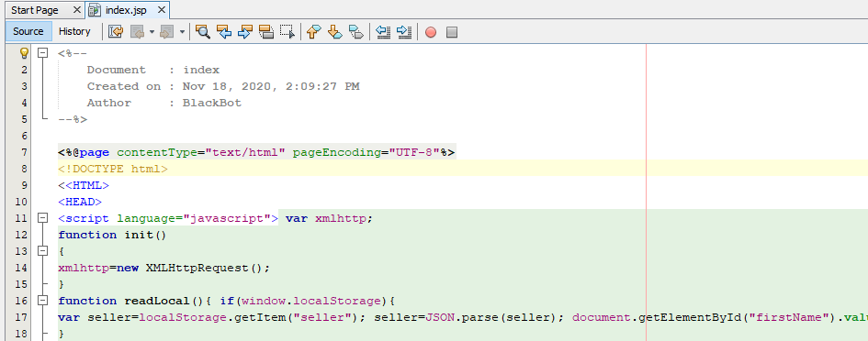

9) <http://localhost:8080/CRUD_Operation/webresources/com.kk.seller/>

Red part is the URL of which is obtained in browser by running of

CRUD_Operation web application.

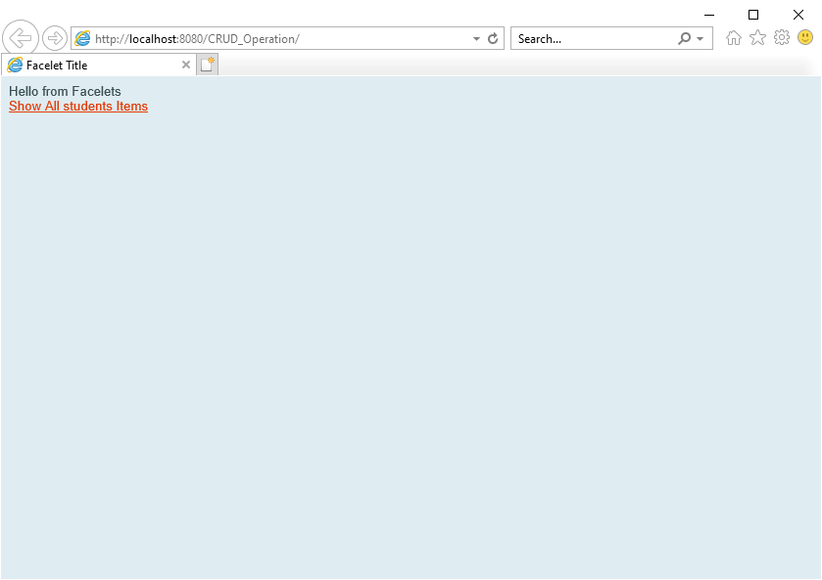

**Blue part** in above link is static. But red part is dynamic which is based on

practical 7. So if you have changed name anywhere then the above URL will

change accordingly.

10) Now open studentsFacadeREST.java file by follow below pic available in

CRUD_Operation web application.

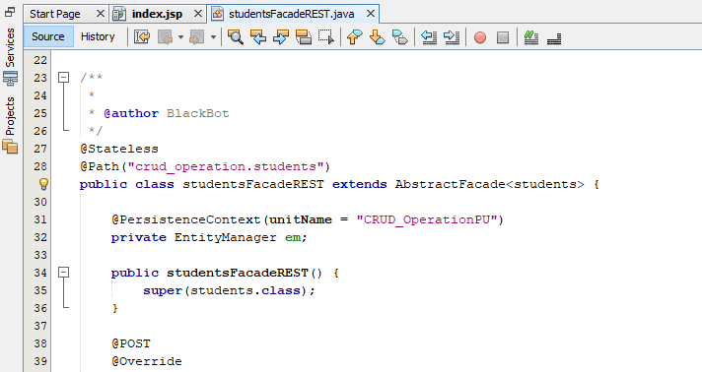

11) Now delete the selected part. Because it will return data in XML format to the

consumer.

But we have written javascript in index.jsp for JSON data format

only.

After that deploy the **CRUD_Operation** web application; so that it will

update the changes.

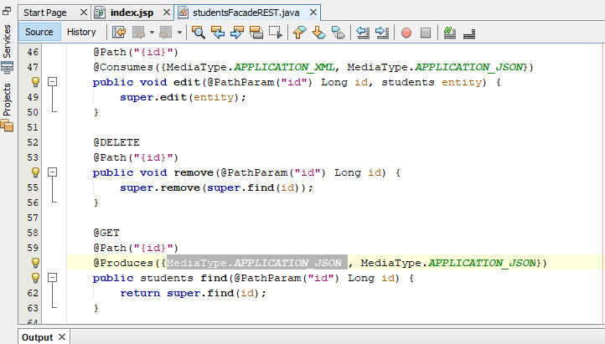

12) Now run the Consumer application. A window will open in browser like

below.

13) Now if you will enter an id into Enter id textbox which you have created in

database (id from data in last step of practical 7) and then click on load

employee in local browser button. It will get the detail of particular entered id

and will store it into local storage of browser. Now click on Send Values to get

the first name of entered id.

